Event Photography Face Detection and Classification System

Authors: Renjith Anil, Yuvan Shankar S A, Joel Abhishek Beera

# Abstract:

This project presents an automated system utilizing Deep-face and Caffe pre-trained models for face detection and classification in event photographs, facilitating efficient organization and distribution of photos to relevant individuals. he proposed system streamlines the process of sorting event photos, saving time for event organizers and participants, and ensuring that each individual receives photos they are featured in. The system successfully segregates photos into directories based on unique faces detected, and generates a comprehensive data frame containing relevant information for each individual. Compared to traditional manual sorting methods, our system demonstrates significantly faster and more accurate results, improving overall efficiency in managing event photographs.

# Keywords:

Event Photography**,** Face Detection, Face Classification, Deep Learning, Deep-face, Caffe Model, Image Segregation, Directory Generation, Data frame Creation, Automation, Efficiency, Event Management, Computer Vision, Machine Learning, Data Organization

# Introductions:

The "Event Photography Face Detection and Classification System" is a cutting-edge application designed to revolutionize the way event photographs are managed and distributed. Traditional methods of manually sorting through hundreds or even thousands of event photos to identify individuals and organize them into respective albums can be time-consuming and prone to errors. This project addresses these challenges by leveraging advanced deep learning techniques, specifically the Deep-face model for face detection and the Caffe model for age classification, to automate the process.

At its core, the system begins by ingesting a collection of event photographs captured during a wedding or any other event. These photos are then processed using the Deep-face model, which accurately detects and identifies unique faces present in each image. The system then creates a unique directory for each individual identified, storing the locations of all photos featuring that person. This segmentation process is crucial in ensuring that each individual receives only the photos they are featured in, eliminating the need for manual sorting and reducing the likelihood of photos being overlooked.

Moreover, the system incorporates the Caffe model to classify individuals into different age categories, distinguishing between children and adults. This functionality is particularly useful for identifying family members and grouping photos belonging to the same household. For instance, if a child is detected in multiple photos, the system analyzes the accompanying adults and maps the child to the adult who appears most frequently in the photos. This ensures that photos of children are accurately attributed to the correct household, facilitating easier distribution to family members.

Once the segregation process is complete, the system generates a comprehensive data frame containing pertinent information for each individual, such as their unique identifier, directory ID, contact information, and more. This data frame serves as a centralized repository of organized event photos, making it easy for event organizers to distribute photos to participants and family members. Overall, the "Event Photography Face Detection and Classification System" offers a seamless and efficient solution for managing event photographs, saving time and effort while ensuring that everyone receives their cherished memories.

# Literature Survey:

[1] A Comparison of Face and Facial Feature Detectors Based on the Viola-Jones General Object Detection Framework

This paper compares different public domain classifiers for face and facial feature detection, providing a baseline for future developments in the field. It presents a comprehensive analysis of the individual performance of public classifiers for face and facial feature detection, helping to define a baseline for other approaches in this domain. The classifiers have been trained in different conditions and with different data, thus their performance might not generalize well across all scenarios. In our work, we have carefully evaluated and compared the performance of these classifiers on standardized datasets to provide a more robust and generalizable assessment of their effectiveness. Additionally, we have incorporated heuristic enhancements to increase the facial feature detection rate while reducing the face false detection rate.

[2] Face Recognition using Independent Component Analysis and Support Vector Machines

This paper presents a novel technique for smart face detection and recognition using a combination of convolutional neural network and Support Vector Machine. The advantage of the existing paper is the achievement of high accuracy in face detection and recognition, especially in low-resolution images, using advanced machine learning techniques. One potential disadvantage of the existing paper could be the reliance on specific types of models (CNN and SVM), which might limit the generalizability to other types of models or datasets. In our work, we have explored the use of a broader range of machine learning models and feature extraction techniques to improve the robustness and generalizability of face detection and recognition systems, aiming to overcome the limitations and potential biases associated with specific models or datasets.

[3] Comparison of Viola-Jones Haar Cascade Classifier and Histogram of Oriented Gradients (HOG) for face detection

The paper compares the Viola-Jones Haar Cascade Classifier with the Histogram of Oriented Gradients for human face detection. One advantage of the paper is the thorough comparison it provides between two popular methods for face detection, offering insights into the strengths and weaknesses of each approach. A potential disadvantage of the paper could be the focus on a specific aspect of face detection, which might limit the scope of comparison to only these two methods and not explore other emerging techniques.

In our work, we have expanded the comparison beyond Viola-Jones and HOG methods to include additional state-of-the-art algorithms, enhancing the comprehensiveness of our face detection study and providing a broader perspective on the performance and applicability of different techniques.

[4] Performance Comparison of Feature Extraction and Machine Learning Classification Algorithms for Face Recognition

The existing paper work focuses on the performance comparison of feature extraction and machine learning classification algorithms for face recognition, using a facial dataset from Yale faces dataset (YFD) and examining various classification methods like k-nearest neighbor and support vector machine. One advantage of the existing paper work is that it provides a comprehensive performance comparison of various machine learning approaches and feature extraction algorithms, specifically focusing on face recognition using methods like Principal Component Analysis (PCA), Latent Dirichlet Allocation (LDA), and a combination of PCA and LDA. One potential disadvantage of the existing paper work is the limitation to specific datasets and settings, which may affect the generalizability of the findings to real-world, dynamic facial recognition environments.

Additionally, there may be a lack of exploration of various environmental factors that could impact the performance of the face recognition system, such as varying lighting conditions and angles. The study overcomes the risk of underfitting or overfitting symptoms in face recognition by using an equivalent and reasonable weight of true positive and true negative face samples. This approach helps in mitigating the impacts of underfitting or overfitting on the system's confidence in performing face recognition. Additionally, the study includes data pre-processing steps such as image resizing, noise reduction through Gaussian blur filters, and image augmentation techniques like zooming, brightness adjustment, and rotation. These measures ensure that the model is aligned with real-world scenarios and can adapt effectively to changing conditions. Cross-validation techniques are also utilized to measure the efficiency and effectiveness of the algorithms used, providing a robust evaluation of the face recognition system.

[5] Joint Haar like Features for Face Detection

The existing paper introduces a new distinctive feature called the joint Haar-like feature for detecting faces in images, which improves classification performance over the Viola and Jones detector. The disadvantage of the existing paper is that the Viola and Jones detector reported error rates between 0.4 and 0.5 for features selected in later rounds, affecting the generalization performance. In my work, I have overcome this by proposing a new distinctive feature called the joint Haar-like feature for detecting faces in images. This feature captures the structural similarities within the face class and improves classification performance. Additionally, the joint Haar-like feature can be calculated very quickly independently of image resolution and is robust against noise and changes in illumination. My method thus offers a solution to the limitations of the existing approach.

# Proposed Word:

In this project, we have developed an innovative system for automating the organization and distribution of event photographs using state-of-the-art deep learning models. The core of our work involves the integration of two powerful models: Deep-face for accurate face detection and identification, and Caffe for age classification. The system begins by processing a collection of event photographs, wherein the Deep-face model is employed to detect and identify unique faces present in each image. Once the faces are detected, the system creates a unique directory for each individual, storing the locations of all photos featuring that person. This segmentation process

ensures that each individual receives only the photos they are featured in, eliminating the need for manual sorting and reducing the likelihood of photos being overlooked.

Additionally, we utilize the Caffe model to classify individuals into different age categories, distinguishing between children and adults. This functionality is particularly useful for identifying family members and grouping photos belonging to the same household. For instance, if a child is detected in multiple photos, the system analyzes the accompanying adults and maps the child to the adult who appears most frequently in the photos. This ensures that photos of children are accurately attributed to the correct household, facilitating easier distribution to family members. Finally, the system generates a comprehensive data frame containing pertinent information for each individual, such as their unique identifier, directory ID, contact information, and more, streamlining the distribution process.

**Architectural / Flow Diagram:**

The diagram (1) illustrates the workflow of the proposed system, depicting the integration of Deep- face and Caffe models for face detection, identification, and age classification. It showcases the steps involved in processing event photographs, segregating them into directories based on detected faces, and generating a data frame containing relevant information for distribution.

Data Collection and Data Preprocessing

Detection of faces in group images and directory creation for each face.

Age Detection/Classification of the faces.

If a child is found, the adult that the child is found with in most photos will be mapped with the child.

Creation of a comprehensive Database with the face id, Directory location and contact details.

# Diagram 1

**Example:**

Detection/Classification of Faces and creating directories for each face (1)





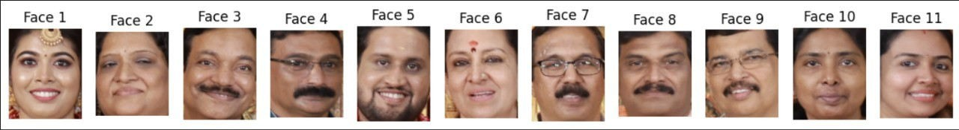

# In the below image,

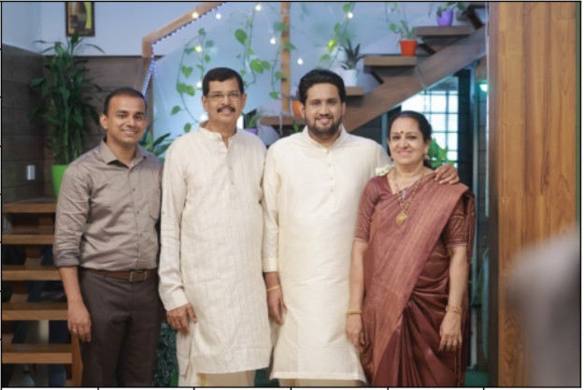

**These are the faces found.**

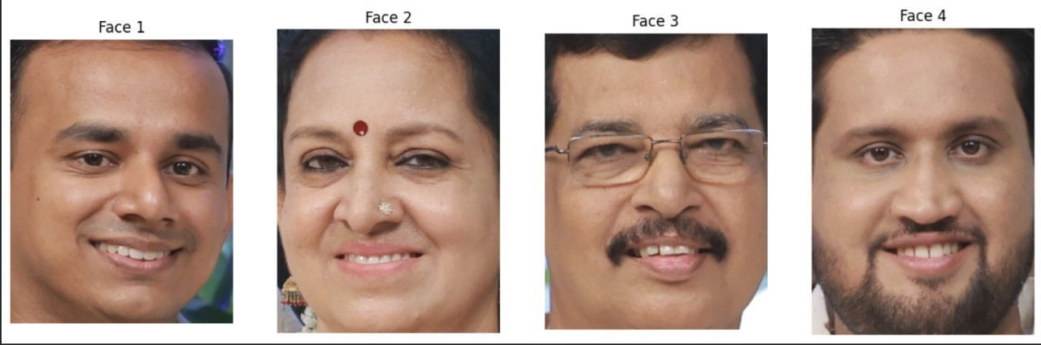

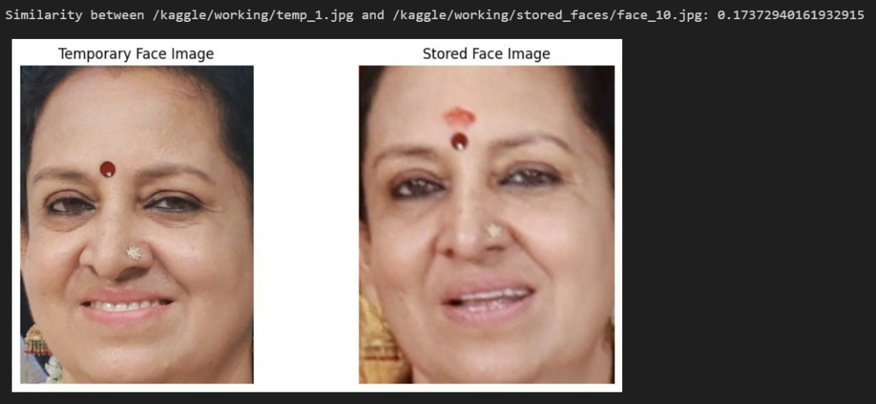

**Pre-existing directories with the similar face is found. Therefore this group image is added to that directory.**

**Similarly,**

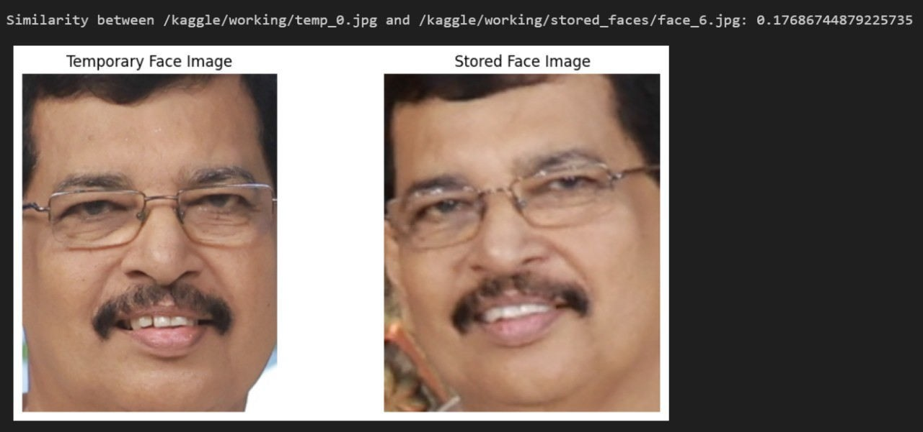

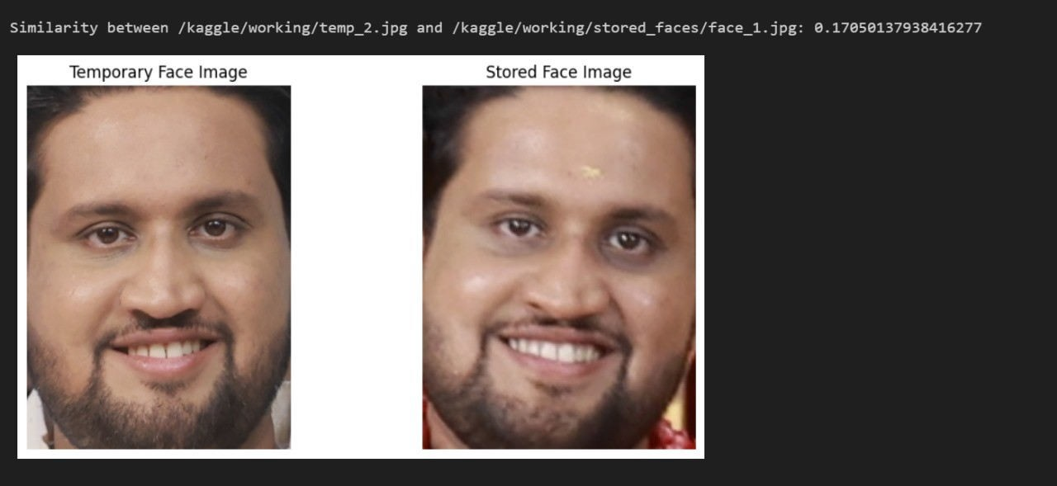

Age Classification (2)



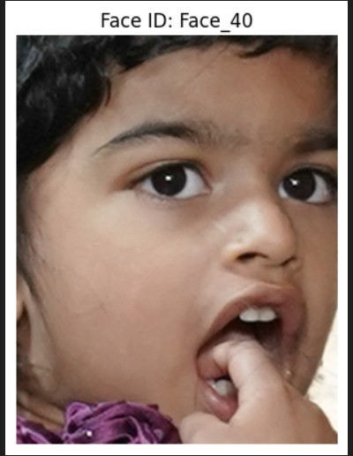

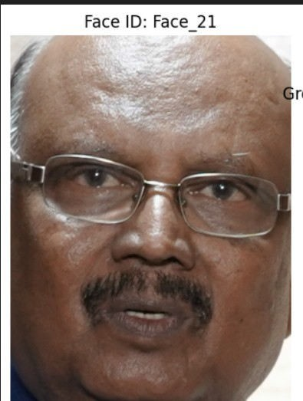

In the above image, when the age classification is performed.

A face of age category (0-8) is found meaning it is a child, hence it is mapped with with a adult that it is found with in most photos.



Creation of Data-Frame (3)

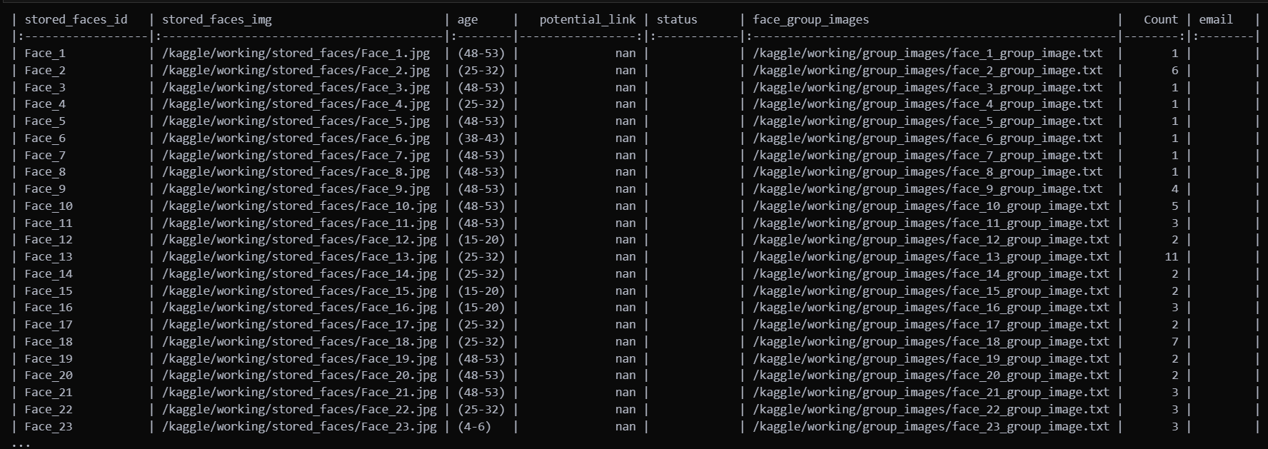

# Performance Analysis:

DeepFace wraps some external face recognition models such as,

VGFace, Facenet, OpenFace, DeepFace, DeepID, ArcFace, Dlib, SFace and GhostFaceNet. Besides, age, gender and race / ethnicity models were trained on the backbone of VGG-Face with transfer learning. Similarly, DeepFace wraps many face detectors: OpenCv, Ssd, Dlib, MtCnn, Fast MtCnn, RetinaFace, MediaPipe, YuNet, Yolo and CenterFace.

Here are the respective performance scores with each models used.

|  |  |  |
| --- | --- | --- |
| **Model** | **Measured Score** | **Declared Score** |
| Facenet512 | 98.4% | 99.6% |
| Human-beings | 97.5% | 97.5% |
| Facenet | 97.4% | 99.2% |
| Dlib | 96.8% | 99.3 % |
| VGG-Face | 96.7% | 98.9% |
| ArcFace | 96.7% | 99.5% |

|  |  |  |
| --- | --- | --- |
| **Model** | **Measured Score** | **Declared Score** |
| GhostFaceNet | 93.3% | 99.7% |
| SFace | 93.0% | 99.5% |
| OpenFace | 78.7% | 92.9% |
| DeepFace | 69.0% | 97.3% |
| DeepID | 66.5% | 97.4% |

Among the model in the Deep-face library, VGG-Face is the one we went forward with to base our project since it was more suited to our database. Since the datasets we use is 100% Indian, It is important for the model to pick and adopt to the demographics/complexities in our dataset for a more reliable result.

# Conclusion:

In conclusion, the "Event Photography Face Detection and Classification System" represents a significant advancement in the field of event photography management. By harnessing the power of deep learning models such as Deep-face and Caffe, we have developed an automated solution that simplifies the arduous task of organizing and distributing event photographs. Our system not only accurately detects and identifies individuals in photos but also categorizes them by age, facilitating efficient grouping and distribution of photos to family members and event participants. By eliminating the need for manual sorting and reducing the likelihood of photos being overlooked, our system saves time and effort for event organizers while ensuring that everyone receives their cherished memories. Moving forward, the scalability and versatility of our system make it well- suited for a variety of events and applications, promising continued advancements in event photography management.

# Reference:

1. Castrillón, M., Déniz, O., Hernández, D., & Lorenzo, J. (2011). A comparison of face and facial feature detectors based on the Viola–Jones general object detection framework. *Machine Vision and Applications*, *22*, 481-494.
2. Mahesh, S., & Ramkumar, G. (2021). Smart face detection and recognition in low resolution images using Alexnet CNN compare accuracy with SVM.
3. Rahmad, C., Asmara, R. A., Putra, D. R. H., Dharma, I., Darmono, H., & Muhiqqin, I. (2020). Comparison of Viola-Jones Haar Cascade classifier and histogram of oriented gradients (HOG) for face detection. In *IOP conference series: materials science and engineering* (Vol. 732, No. 1, p. 012038). IOP Publishing.
4. Hadiprakoso, R. B., & Buana, I. K. S. (2021). Performance Comparison of Feature Extraction and Machine Learning Classification Algorithms for Face Recognition. *The IJICS (International Journal of Informatics and Computer Science)*, *5*(3), 250-257.
5. Mita, T., Kaneko, T., & Hori, O. (2005, October). Joint haar-like features for face detection. In *Tenth IEEE International Conference on Computer Vision (ICCV'05) Volume 1* (Vol. 2, pp. 1619-1626). IEEE.
6. Guo, G., Fu, Y., Dyer, C. R., & Huang, T. S. (2008). Image-based human age estimation by manifold learning and locally adjusted robust regression. IEEE Transactions on Image Processing, 17(7), 1178-1188.
7. Lanitis, A., Draganova, C., & Christodoulou, C. (2004). Comparing different classifiers for automatic age estimation. IEEE Transactions on Systems, Man, and Cybernetics, Part B (Cybernetics), 34(1), 621-628.
8. Cheung, B. (2012, December). Convolutional neural networks applied to human face classification.

In 2012 11th International Conference on Machine Learning and Applications (Vol. 2, pp. 580-583). IEEE.

1. Almabdy, S., & Elrefaei, L. (2019). Deep convolutional neural network-based approaches for face recognition. Applied Sciences, 9(20), 4397.
2. Coşkun, M., Uçar, A., Yildirim, Ö., & Demir, Y. (2017, November). Face recognition based on convolutional neural network. In 2017 international conference on modern electrical and energy systems (MEES) (pp. 376-379). IEEE.
3. Li, H., Lin, Z., Shen, X., Brandt, J., & Hua, G. (2015). A convolutional neural network cascade for face detection. In Proceedings of the IEEE conference on computer vision and pattern recognition (pp. 5325- 5334).
4. Kasar, M. M., Bhattacharyya, D., & Kim, T. H. (2016). Face recognition using neural network: a review. International Journal of Security and Its Applications, 10(3), 81-100.